**Interview Questions Asked by Various Companies:**

**Why API KIT Router?**

It is Used for the service as Rest or SOAP.

In Mule 3 it was embedded with Runtime but In Mule 4 it is given as Plug in.

We can Changes the API Kit Router version using POM.XML in Mule 4 but Mule 3 we cannot.

It will do Header and QueryParameter Validation Also but we need to Enable to validations for Header and QueryParam.

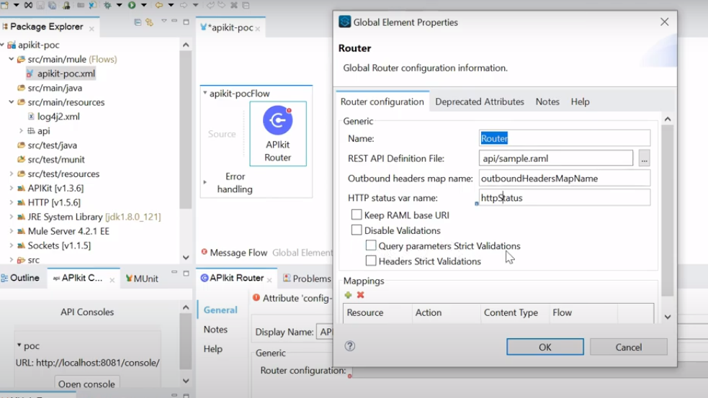

**What is difference BW Flow reference and Lookupmethod?**

Flow reference we can call Private and Sub Flows but Lookup will call only Private Flow and it will be used only in Data Waeve.

**3.Can we used method or functions in Flow Reference?**

In Choice we will use When function but we don’t use methods in Flow Reference

**4.What are the versions used in your project?**

4.3 mule runtime

1.0 RAML

2.0 Data Weave

7.10 AnyPoint Stdio

**5.What is the Code coverage Maximum set inMUnit?**

Code Coverage Limit in MUnit : Code coverage 85

**6.Difference bw Put and Patch?Http Codes?**

Both will be used for Update the data and both will returns 204 no content.

Put will expect whole Object for Updating single Field but Patch we can pass the exact Field data which we need to update. Using path we can reduce the input payload data

**7.What is Idempotent Method?why?**

PUT.It will return always sameresults if you run multiple times with same data.

**8.What mule-artifact.json file contains?**

It is used for keep mule version and what all the Secures properties keys or Mask the properties keys.

**9.How the API LED Connectivity will work in you application?**

**Mule event structure ?**

mule msg(payload and attr) and Variable.

**mule3 and mule-4 dfrnce?**

We have different variables in Mule 3 but in Mule 4 only one.We have single Connector for insert or select or update or delete in Mule 3 but we have separate connectors in Mule 4.

**Structure of Mule4?**

**Mule domain projects ?**

We are using Cloud Hub Deployments and not aware of it.

**Connectors you have been used ?**

How do you configure http listener ? ports for http and https?

TLS?

Scheduler ? watermarks?

APIKit Router ?

map, mapobject,pluck,flatten, reduce?

FTP, SFTP?

What is traits ? ==>> only one direct question :)

How you will refer secure properties file properties in mule DW transform message

Why Mulesoft provided active MQ and platform MQ both

GIT CICD pipeline ?

What is the main use of Batch process

AsyncScope, cache scope, objective store and retrive?

secure configuration properties ?

What is the function you will use in Flow reference ?

dfrnce btwn flows?

what is the difference between Mule lookup and Flow reference

what is RAML and how do you define that , and what is the structure of RAML?

quer.params, uri.params, libraries, frangments?

API Auto discovery?

What is the relation btwn API Manager, Runtime manager and Design ?

What are all the properties u will mention in Runtime manger under properties tab ?

Scatter-Gather?

**difference btwn continue and propagate?**

**$ and $$ in map ?**

What is Resource Type and Traits in RAML ? What is teh key which is used to call traits ?

(is)

**Scaling ?**

Vertical (worker size) and horizontal(workers) scaling

What is the mule runtime u have used ?

**what is the verion of anypoint studio?**

**what is the latest version of RAML ?**

latest verion 2.0

**whcih version of RAML Design centre will support and which one you are using ?**

1.0 and 0.8 supports , using 1.0

**DW Version ?**

2.0

**How much you rate for DW and RAML ?**

7

**What are the components you have known from Anypoint Platform ?**

**Few error scenarios, they will give and ask us which error we will get with on error continue and propagate ?**

**Raise error ?**

**have you workes on soap services ? if yes how do you configure?**

**Have worked on email configuration?**

**until successfull?**

(HTTP:CONNECTIVITY to MULE:RETRY_EXHAUSTED )

**for-each and parallel for-each dfrnce?**

**scatter gather, choice, for ?**

**worked on salesforce configuration , if yes how do you configure ?**

**Error handler ?**

**Munits?**

**Applying policy, which policy have you applied or worked on ?**

Ratelimitting , client id enforcement

**Http methods? and http error codes ?**

**Invoking java methods using mule app?**

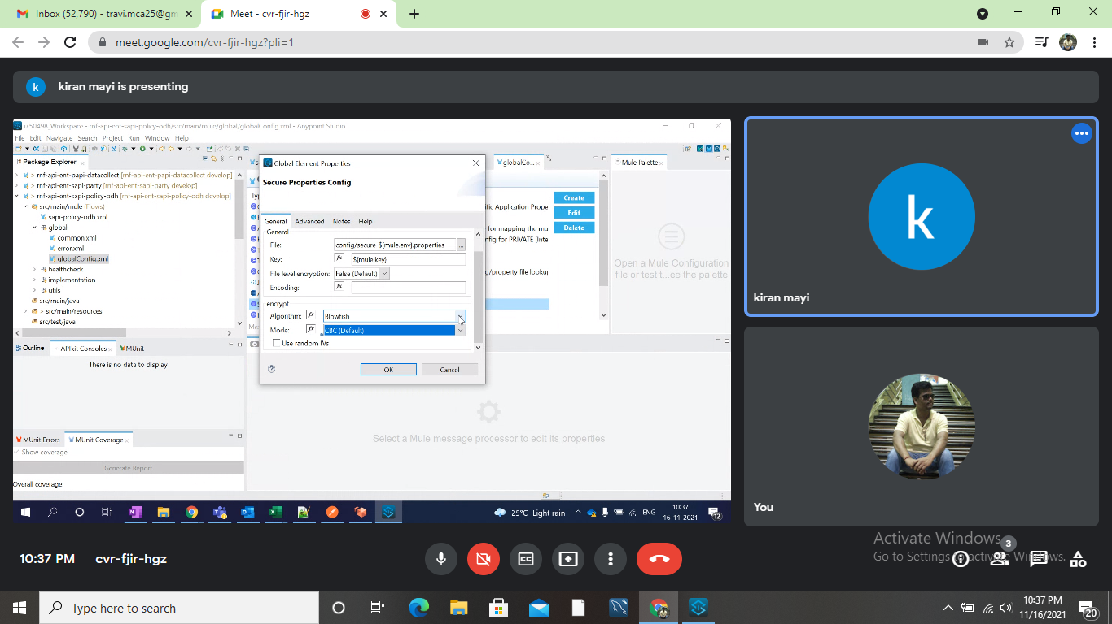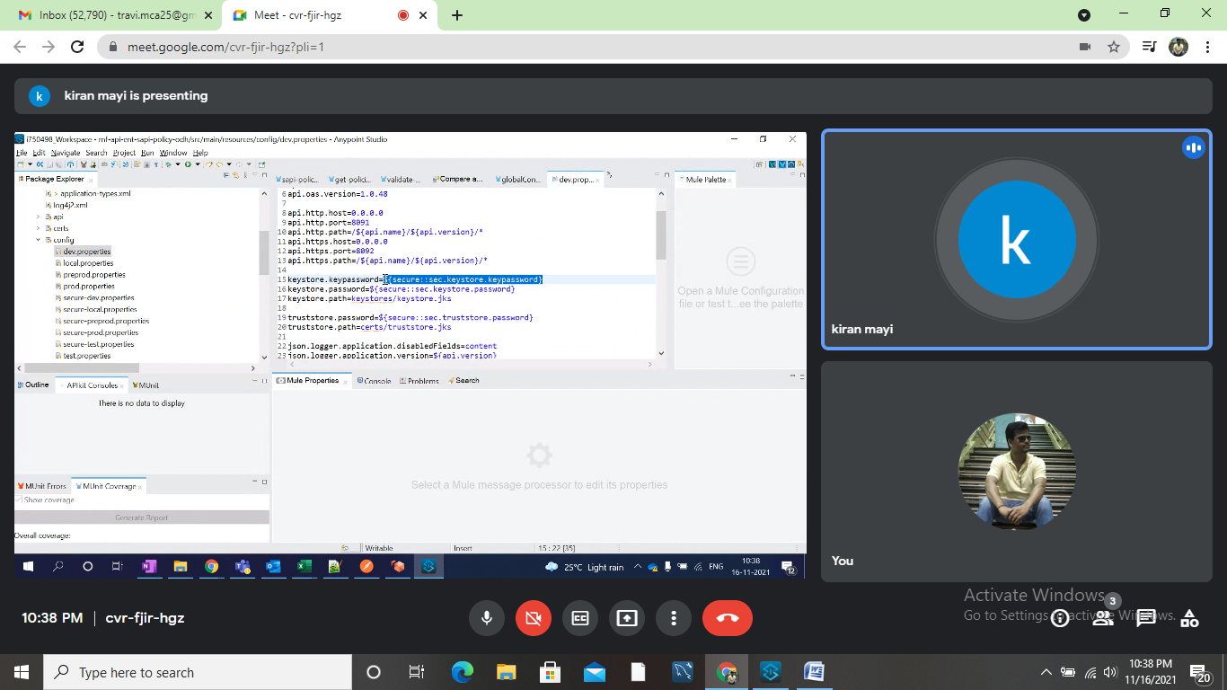

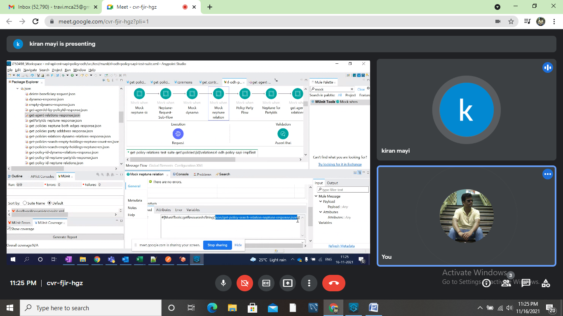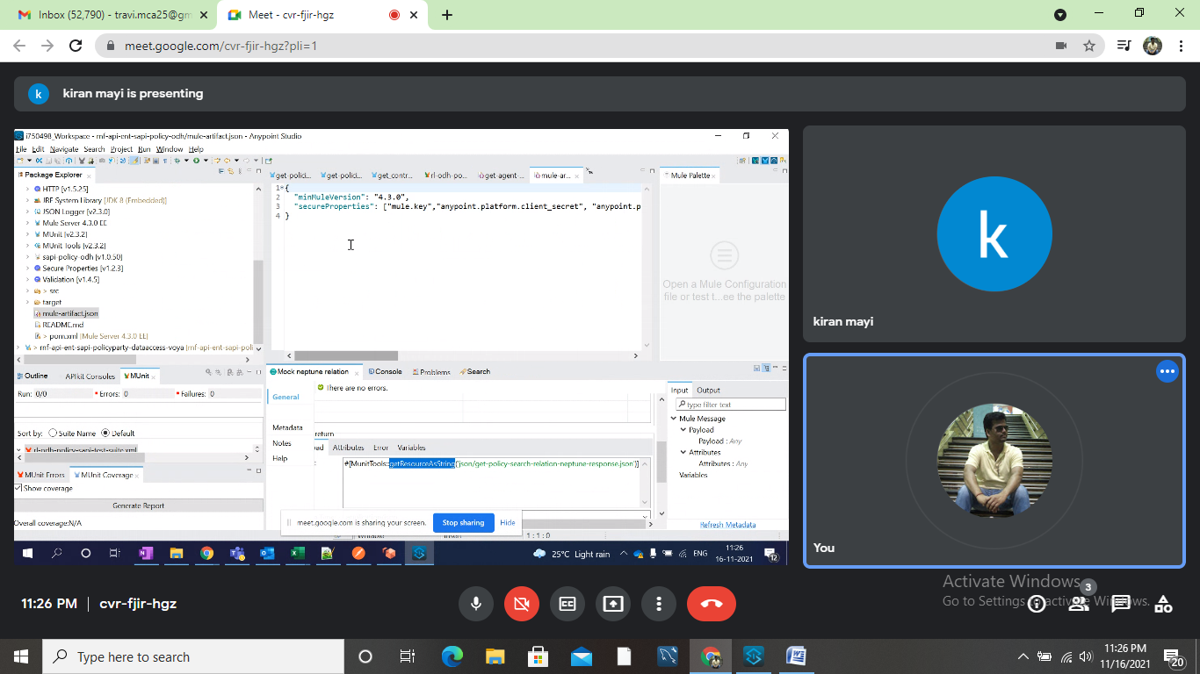

**Practice need to do::**

**1. Need to Practice Data Weave on map,MapObject,Flatten,Reduce,FlatMap .. etc ? XML to Jason and JSON to XML?**

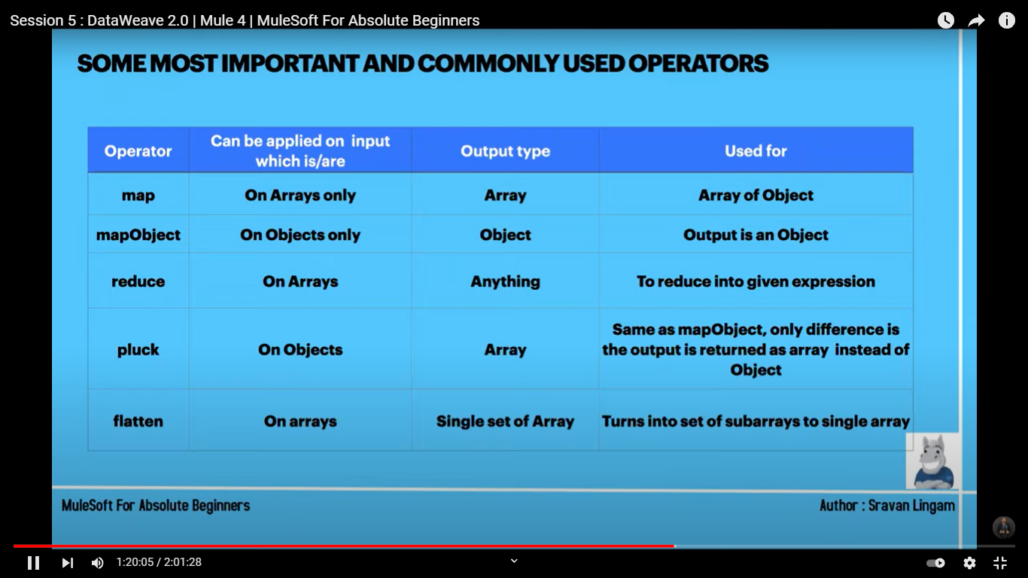

# CONVERT ARRAY TO STRING :

I/P: [1,2,3,4,5]

Logic: payload joinBy ("-")

o/p: "1-2-3-4-5"

# CONVERT STRING TO ARRAY

Ex1 : i/p : “Hello World”

Logic : payload splitBy (" ")

O/p: ["Hello","world"]

Ex2:

I/P : "Hello.world.Ravi"

Logic : payload splitBy (".")

o/p : [

"Hello",

"world",

"Ravi"

]

**Iterate Fixed Number of Elements:**



# JSON TO CSV:

# 

# Date Related Practice:

# 

# Dates in DataWeave follow the ISO-8601 standard and literals are defined between “| “characters.

# The language has the following native date types:

# Date

# DateTime

# LocalDateTime

# LocalTime

# Period

# Time

# TimeZone

# MANIPULATION ON ARRAY

2. DataBase Insert, BulkInsert, Update, BulkUpdate, Delete, Select?

3. JMS Publisher, Consumer? Queue and Topic?

4. JMS over REST?

5. Rest over JMS?

6. ForEach, Choice and Scatter-Gather?

7.Untill Successful?

8. Scheduler? Corn Expressions need to practice?Email sending?

9. RAML Design?

10. Application deploy in CLOUD?

11. Apply Policies?

**Project name : VGT Telematics**

**Project Architecture:**

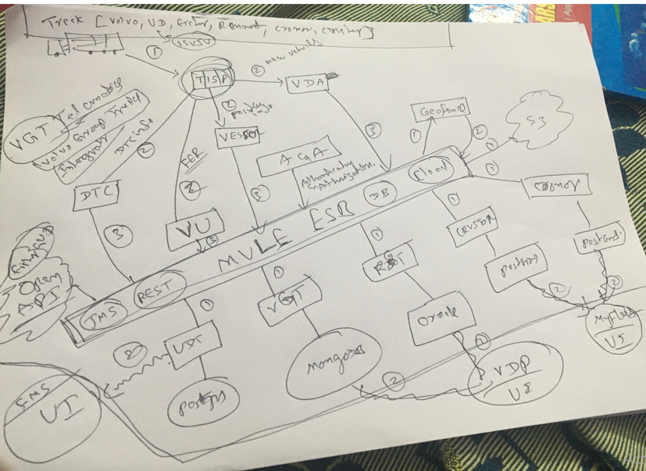

**Requirement Gathering:**

**Brands to Support:** VOLVO,UD,EICHER,CRONER,CROSTOR

**Modules:** Track,Trace,Geofence,New Vehicle Creation,ServiceConversion, Report Generation,Fule Theft Report,DTC Management[Create,Assign,Update,Close],Driver Creation, Auditing.

**Description:**

**VDA :** It will get the data from Vehicles directly and then post to All The vehicles info to Queue for Consuming the down stream systems.

Also it will contains the Service package details.

**Geofence :** UDT will send the vehicle details to Geofence and then Geofence will verify the geofence details and sends back to UDT.

After that if we got the Vehicles position details from if the vehicle enters and exits from geofence then we can send notifications to Customer.

**VESSOR:** It will send position data to All the Down Stream system.

**New Vehicles:**

1. Vehicle will send data to TISP[AMQ] and We will Consume the messages from EventLog.xml and Enrich the data and then Store the data to DB.
2. EventLog.xml contains VIN,VPI,Chassis-ID,Productclause,Country Of Operation,Brand,Occurrence Time,FuelPercentage,TrigerType,Lattitude,Langgitude,Altitude ….Etc.
3. We will get the Event log from TISP and Check the Product clause is UD or Eicher or Renault or Croner or Croster or Volvo then put it into Our DB.

**Track:**

1. If User gives the Vin or chassis or VPI then the latest position details need to return to the User.

**Trace:**

1. Users can See the Report like from last 1 week where and all the vehicle Travelled and we will provide the json with Latitude and Longitudedetails .

**Geofence:**

1. 2.When we will get the Event Log then we will Verify the Vehicles is inside geofence or Out sideGeofence then communicates with email to the Customer.The logic will calculates based on the VIN ,Lattitude ,Langitude,Speed.

**Service Conversion:**

1. We will be Activating the Vehicles with Some packages like Uptime and fleet.If the Customer need the Only fleet services or If he need Uptime services or Both .We can Apply the packages based on User Requirement.

**Fuel Theft:**

1. Suppose The Truck is filled with 100% Fuel and After Driven 100 KM Truck Stoped[ignition off ] and it got reduced to 75% and After 15 mins Again the Truck started[Ignition On] and the Fuel is now 45% And .Here some Fuel theft[Ignf Off 75% after 15 mins Ignf On then 45% that means 30% Fuel is Thefted] Happened and we will send Notification to the Customer with Fuel % , Driver name , VIN,Time ,Location.

**Driver Creation:**

1. Once Drivers can start the Driving Vehicles after 5 mins the driver details we will be Receiving to Our system with Vehicle Details and store in Our System.

**DTC Management:**

1. Vehicles will be Installed with Censors in Engine ,Wheels,Lightes,Beakes …etc for Monitorying how the Performance .TISP will sed us the DTC info then we will be storing to Our system to manages the DTC’s.
2. MSA or SA can assign this to some technicians and after Fixing the issue the Status changes to Closed.
3. **Data Base Design**

|  |  |  |  |
| --- | --- | --- | --- |
| **SNO** | **Table Name** | **Constrains** | **Description** |
| 1 | Vehicles |  |  |
| 2 | User_Masters |  |  |
| 3 | Brands |  |  |
| 4 | Country |  |  |
| 5 | Position_Master |  |  |
| 6 | Drivers |  |  |
| 7 | Vehicle_Driver |  |  |
| 8 | Geofence Details |  |  |
| 9 | Vehicle_Geofence |  |  |
| 10 | Packages |  |  |
| 11 | Vehicle_Packages |  |  |
| 12 | DTC_Info |  |  |
| 13 | Vehicle_DtcInfo |  |  |
| 14 | Market |  |  |

|  |  |
| --- | --- |
| **Source Systems** | **Target Systems** |
| VDA | FMS |
| Geofence | MyFleetVGT |
| VU | RGT |
| VESSOR | Crustor |
| DTC | Cronor |
| A&A | Geofence |
|  | VDA |

Required SW and Tools:

|  |  |
| --- | --- |
| SNO | SW |
| 1 | Java 8 |
| 2 | AMQ |
| 3 | APS |
| 4 | APF |
| 5 | PostMan |
| 6 | MongoDB |
| 7 | Postgres |
| 8 | Oracle |

**Create Design Document:**

**New Vehicle:**

1. **Source System :** VDA
2. **Destination :** UDT DB
3. **SAPI:**
4. **We need to Consume below Services:**

|  |  |  |  |
| --- | --- | --- | --- |
| **URL** | **Input** | **Input** | **Descrition** |
| {BaseURL}/vin/{vin}/CountryOfOperation/{coo}/brand/{brandId} |  |  |  |
| {Base URL}/vin/{vin}/market/{marketId} |  |  |  |
| {Base URL}/vin/{vin}/UpdateVehicle |  |  |  |
| {Base URL}/vin/{vin}/DeleteVehicle |  |  |  |
| {Base URL}/vin/{vin}/market/getVehicleDetails |  |  |  |

1. **No Producers**
2. **JMS:**
3. **Consumers**

|  |  |  |  |  |  |
| --- | --- | --- | --- | --- | --- |
| **Queue Name** | **AMQ URL** | **UserName** | **Password** |  | **Description** |
| VEHICLE.DATA.READ.IN | **Tcp://0.0.0.0:61616/** | **Admin** | **Admin** |  |  |
|  |  |  |  |  |  |

1. **No Producers**
2. **DB:** Vehicles**,**Market,Country,Brand
3. **Flow Diagram**

**3. Design API’s in Design Centre in AnyPointPlatForm:**

**4. Develop API’s:**

**5. Test API’s Using Units**

**6. Manage API’s**

**7. Deploy APIs on Cloud**

**8. Apply Policies**

**References:**

<https://mulesy.com/z-jwtjson-web-token-validation-policy/>

Muel by karthik

basics by Sravan ningam ::

esb by chinaa ::

mulesoft all videos by jitendra

<https://www.youtube.com/watch?v=kjF9sF66EUc&list=PLu8R-CyJmLVkW8uqzz8Lzdyuf3I0noIZQ>